**A Computerized Glow Curve Analysis Software written in C++**

Jeremy M. Hepker*, Jack ?. Thiesen*, Kimberlee J. Kearfott*

Figures Appendix

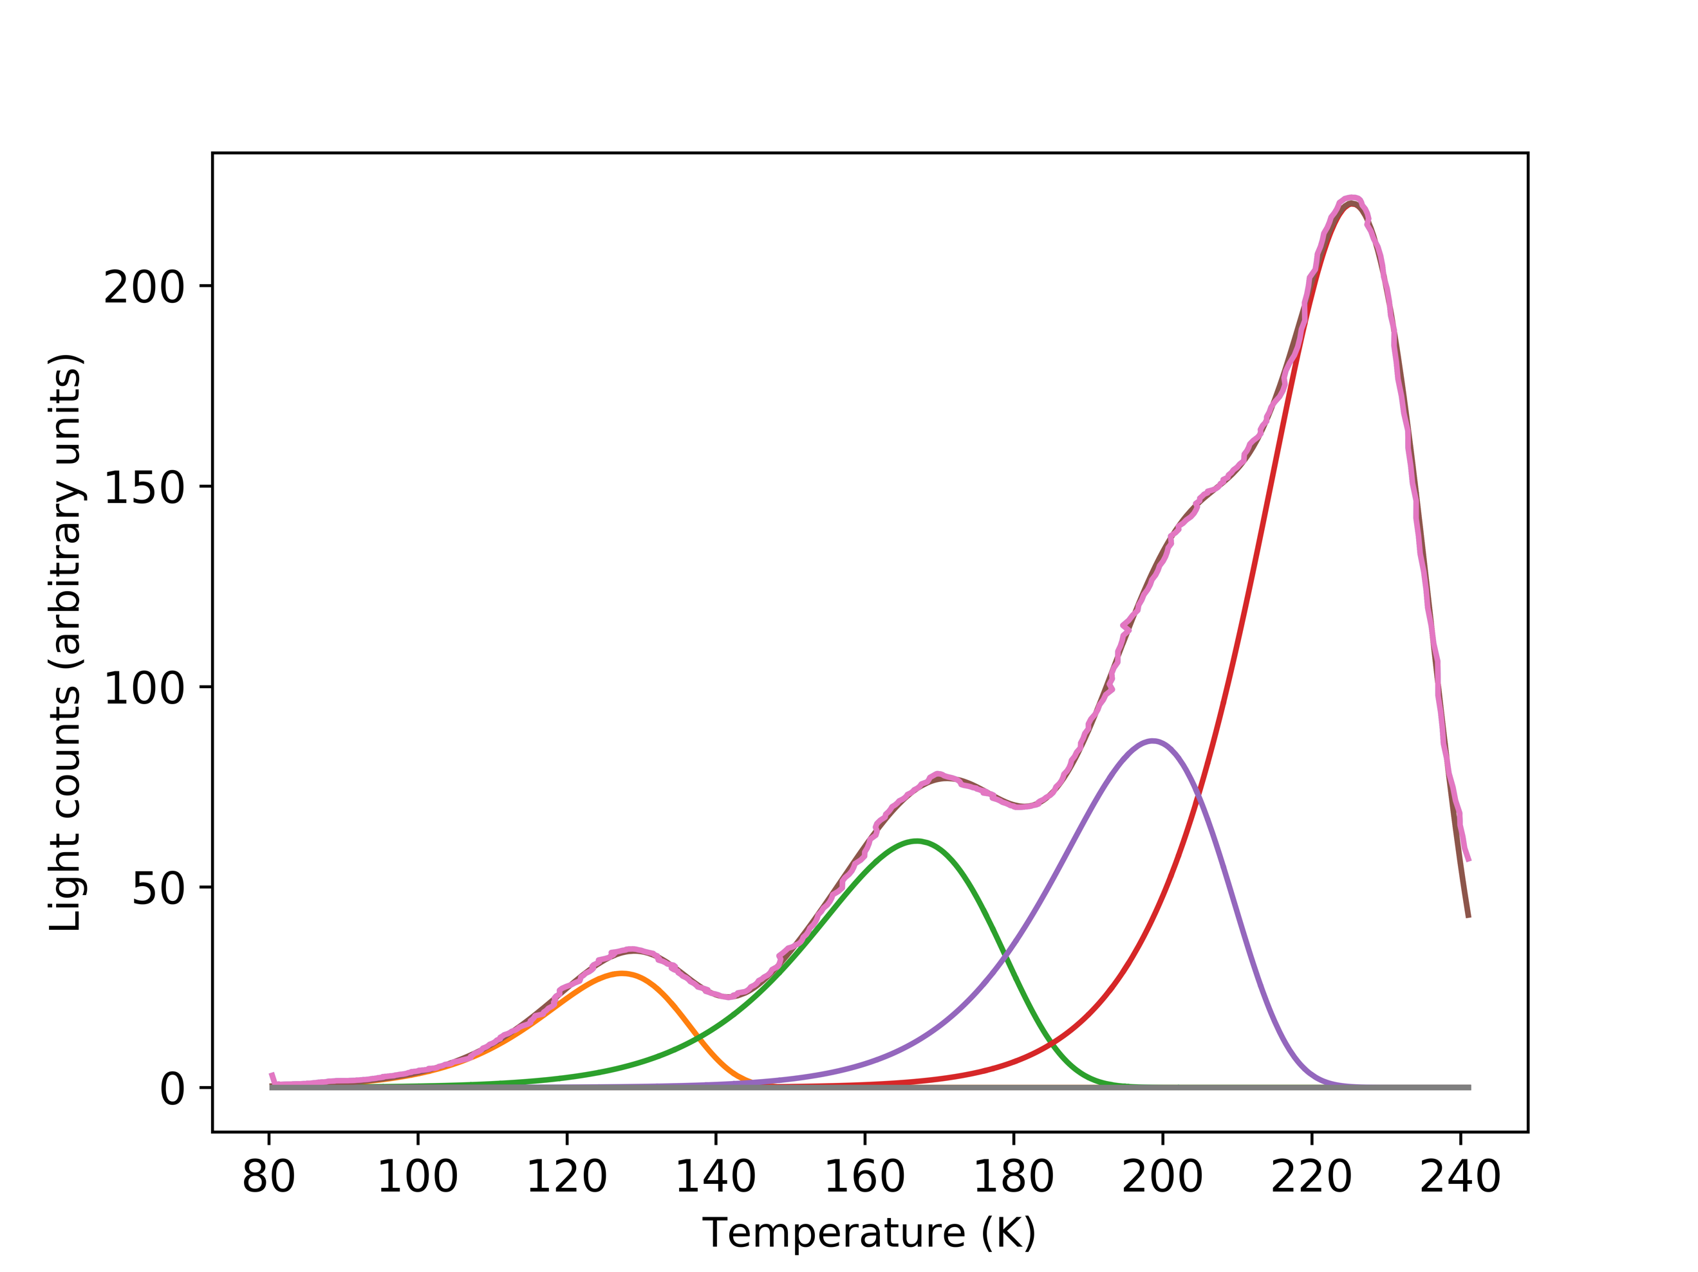

**Fig. 1.** Output of automated computerized glow curve analysis program for LiF:Mg,Ti (TLD-100). The figure of merit is 1.03%.

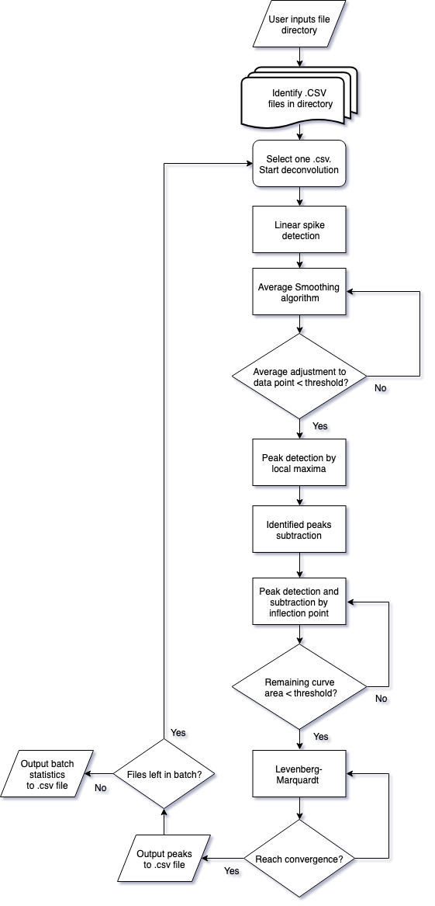

**Fig. 2.** Software flow diagram.

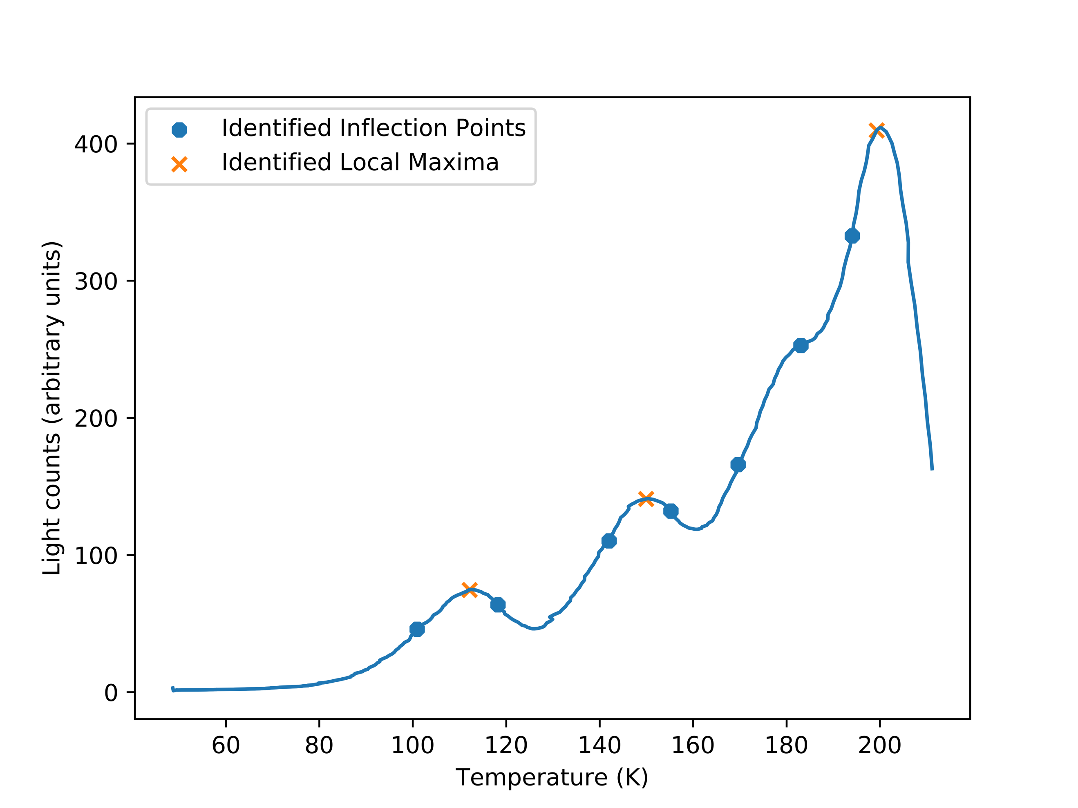

**Fig. 3.** Visual representation of data points identified by the automated peak identification stage.

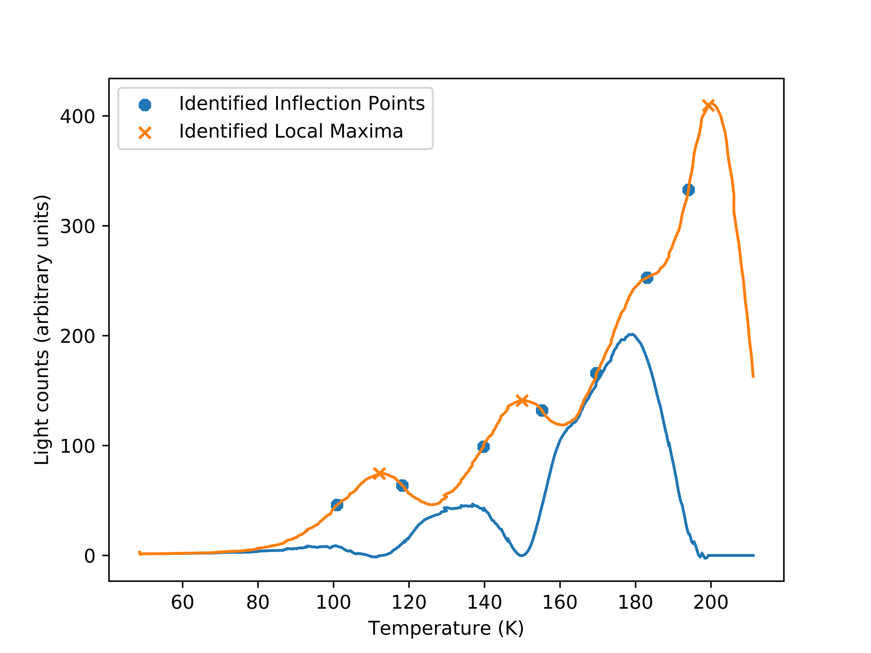

**Fig. 4.** The output emission spectra (orange) and the remaining glow curve after subtracting away glow peaks determined by analyzing the list of local maxima (blue)

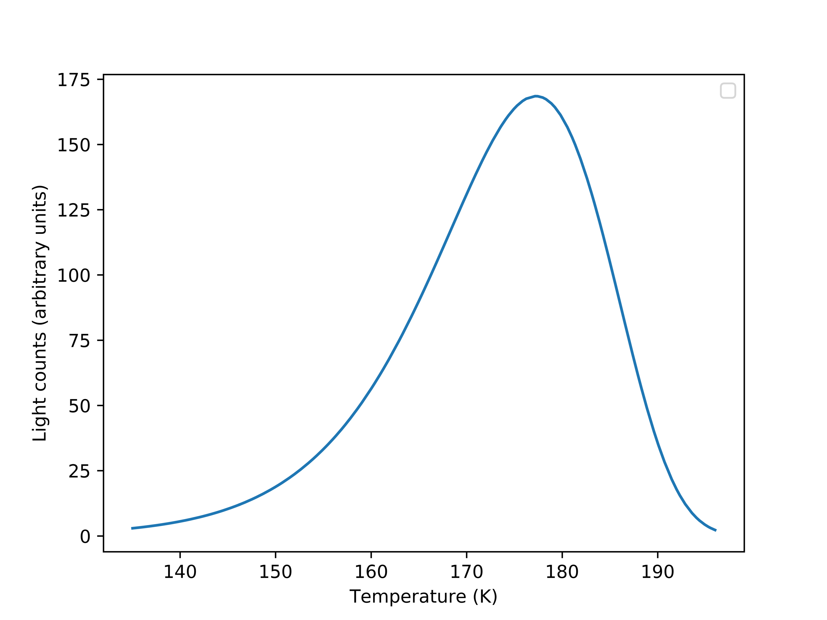

IM

IM/2

TM

T2

T1

w1

w2

**Fig. 5.** The individual fitting parameters which describe a glow peak.

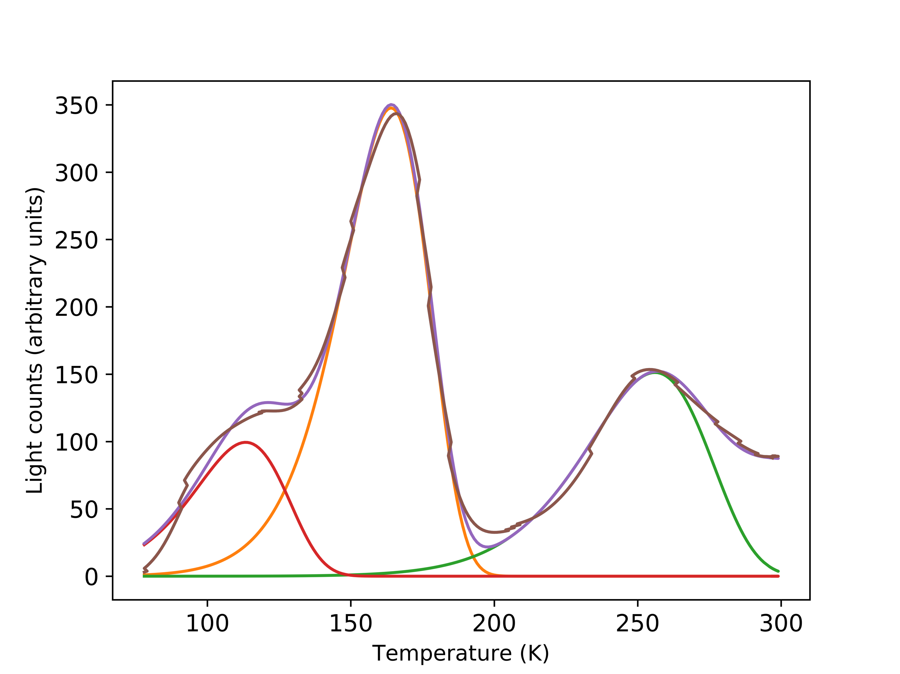

**Fig. 6.** Output of automated computerized glow curve analysis program for CaF2:Tm

(TLD-300). The figure of merit is 5.03%.

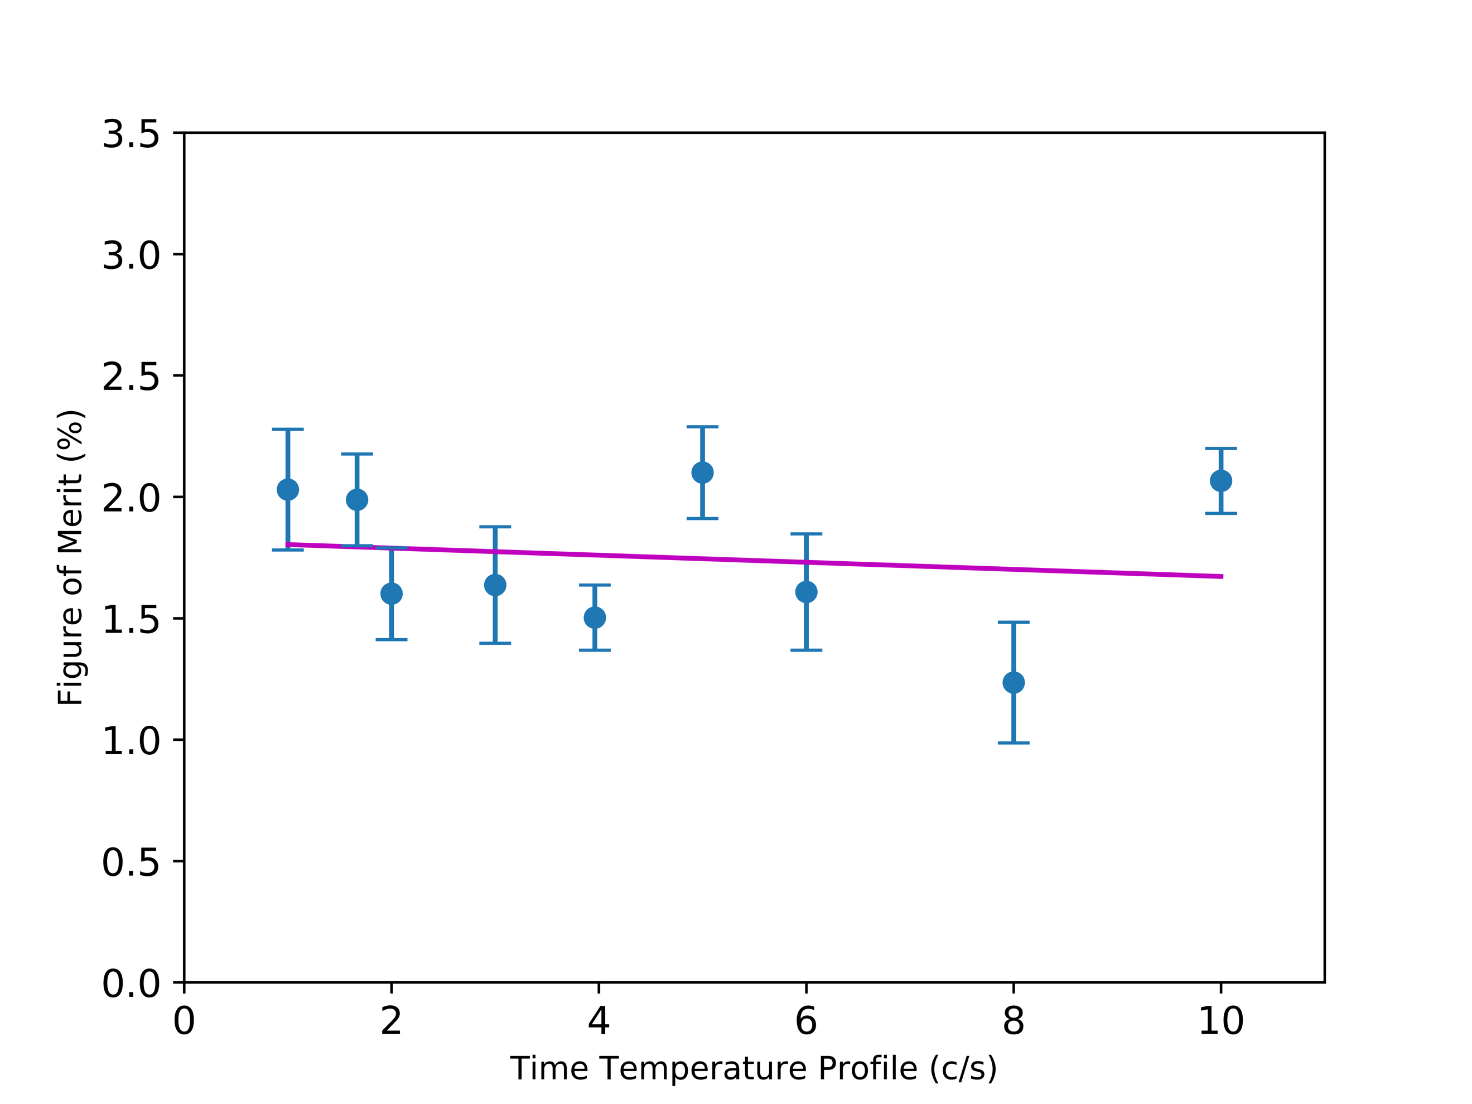

**Fig. 7.** Heating rate vs. figure of merit (FOM). Data from TLD-100. Trend line slope of -0.02% and R2 = 0.0962.

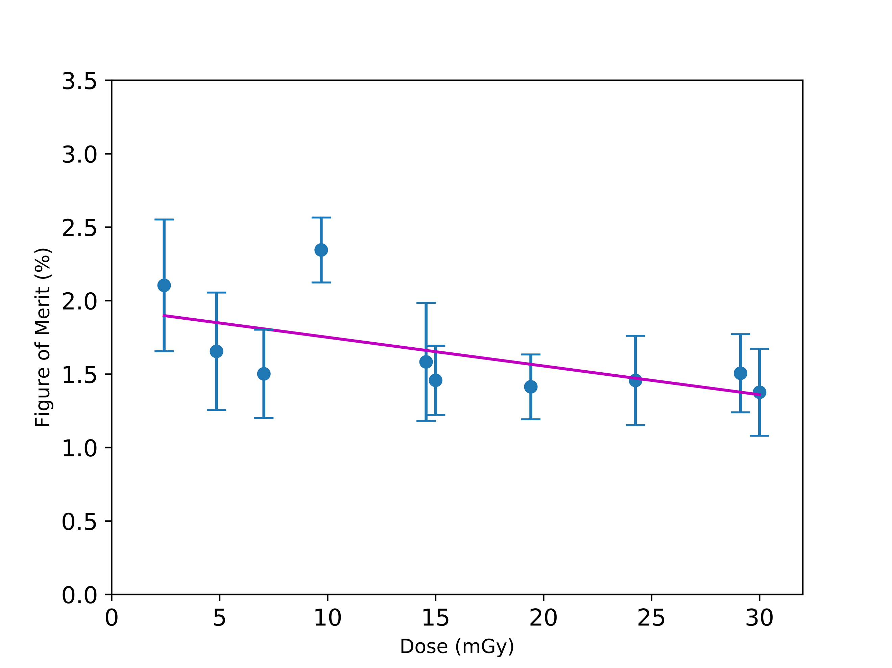**Fig. 8.** Dose vs. figure of merit (FOM). Data from 100 TLDs irradiated in groups of ten to ten different doses. Trend line slope of -0.016% and R2 = 0.203.

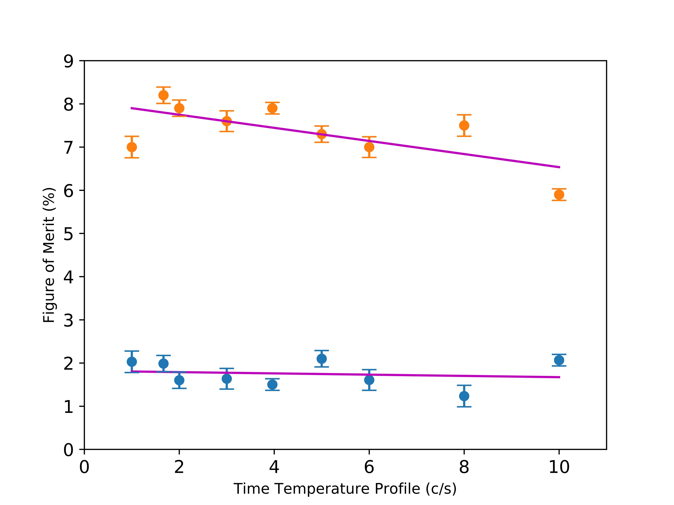

**Fig. 9.** Heating rate vs. figure of merit (FOM). Data from TLD-100, utilizing varying peak detection methods; the subtraction method (orange) and mathematical derivation (blue).